Tutorial

**Question 1:** Adder/Subtractor

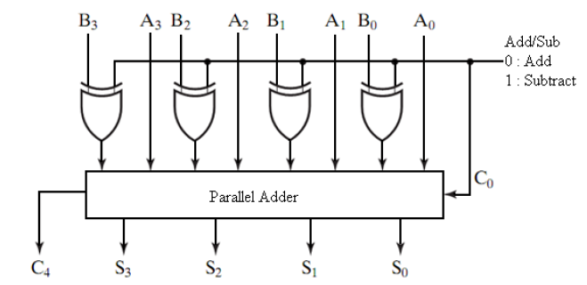

**Figure 1:** Adder/Subtrator Circuit

An adder/subtractor circuit can be designed using the circuit shown in **Figure 1**. Write a VHDL code to represent the circuit by creating XOR component and use the 4-bit Adder created in the previous lab. Then, map all the components. Your code should have 4 design entities (i.e. Full Adder, 4-bit Adder, 4-bit XOR component, top level). Show the RTL schematic and its simulation.

1. Use generate statement for creating the 4-bit parallel adder and the 4 XOR circuit.
2. Combine four 4-bit Adder/Subtractor to produce 16-bit Adder/ Subtractor using the generate statement.